The **council-manager** form of government is used in many cities and municipalities, combining **democratic leadership** with **professional management**. It is designed to promote efficiency and reduce political influence in administrative decisions.

**Org Chart for a Typical Council-Manager Government:**

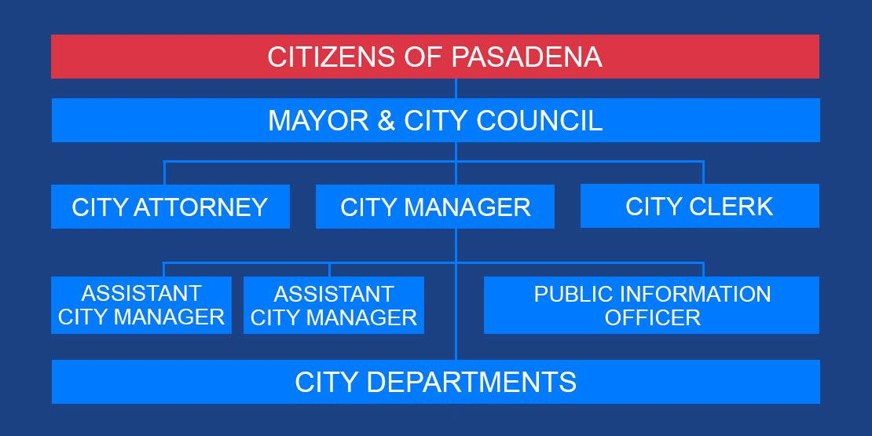

**Key Features of the Council-Manager Government:**

1. **City Council as the Legislative Body**
   * The **elected city council** serves as the policymaking body.
   * **Council sets the city’s vision, approves the budget, and makes all major policy decisions.**
   * **The Mayor is often elected at-large** while **districts typically elect councilmembers**.
2. **Professional City Manager**
   * The **city manager** is appointed by the council to handle daily operations.
   * **City Manager implements council policies**, oversees city staff, and manages the budget.
   * The city manager is a **non-political, trained, and professional administrator** who can be hired or fired by the council.
3. **Mayor’s Role (Varies by City)**
   * In some council-manager cities, the mayor is elected and presides over meetings but has **limited executive power**.
   * In others, the mayor is chosen by the council from among its members and serves a **ceremonial role**.
4. **Separation of Politics and Administration**
   * The council **focuses on big-picture policies**.
   * The manager **focuses on operations** and hires department heads.
   * **This structure helps avoid political interference in day-to-day management**.
5. **Used Mainly in Medium-to-Large Cities**
   * Popular in cities with populations of **25,000+**.
   * Common in states like **Texas, California, Florida, and North Carolina**.
   * Also used in **county governments** and some international cities.

**Pros & Cons of the Council-Manager System:**

✅ **Pros:**

* Promotes **professionalism, competence,** and **efficiency**.
* Studies show that **Council-Manager governments are more transparent, responsive, efficient, and effective.**
* **Reduces political corruption** by keeping administration non-partisan.
* Encourages **long-term planning** rather than short-term political gains.
* **More flexible** — city managers can be replaced if performance is poor.

❌ **Cons:**

* **Less voter control over executive decisions**.
* **Less visible mayor sometimes leads to lower voter turnout.**
* **The mayor has less power than voters often assume.**
* The system relies heavily on the **competence of the city manager**.